ShopEZ — Project Documentation
Full Stack Development with MERN

1. Introduction
Project Title: ShopEZ

- Frontend Development (React, Tailwind CSS, UI/UX)
- Backend Development (Node.js, Express, REST APIs)
- Database Design & Integration (MongoDB, Mongoose)
- Admin Dashboard, Testing & Documentation

2. Project Overview
Purpose: ShopEZ is a full-stack, production-ready Indian e-commerce web application built on the MERN stack (MongoDB, Express, React, Node.js). It mimics real platforms like Amazon India, Flipkart, and Myntra — providing a premium UI, secure authentication, cart and checkout flow, wishlist, and a robust admin dashboard for managing products, users, and orders.
Features:
- Home page with hero banner, category tiles, flash sales, and trending products
- Products page with live search, category/gender filters, and sorting (Popular, New Arrivals, Price Low-High / High-Low)
- Product details page with image gallery, specifications, features, brand, stock status, and quantity controls
- Cart and Checkout flow with shipping address entry and Cash-on-Delivery order placement
- Wishlist for saving products
- JWT-based authentication with role-based redirection (Admin vs User)
- Admin dashboard with revenue/order/user/product analytics, product CRUD with multi-image upload, and order status management

3. Architecture

Frontend
The frontend is built with React 18 and Vite, styled using Tailwind CSS v4, with Framer Motion for animations, React Router v6 for navigation, Axios for API calls, Lucide React for icons, react-hot-toast for notifications, and Chart.js / react-chartjs-2 for analytics charts in the Admin Dashboard. Pages include Home, Products, Product Details, Cart, Checkout, Wishlist, Login/Register, and the Admin Dashboard. An Auth Context stores the JWT token in localStorage and manages user session state across the app.

Backend
The backend is built with Node.js and Express.js, exposing a RESTful API consumed by the frontend. Middleware includes JWT verification for protected routes, bcryptjs for password hashing, and Multer for handling multipart/form-data image uploads. Routes are organized by domain: /api/auth, /api/products, /api/orders, /api/admin, and /api/upload.

Database
MongoDB is used with Mongoose for schema modeling. Key collections:
- User: name, email, hashed password, role (USER or ADMIN)
- Product: title, brand, category, gender, price, discountPrice, stock, description, features (array), specifications (key-value), images (array of URLs)
- Order: user reference, array of products, shippingAddress, totalAmount, status (Pending, Confirmed, Shipped, Delivered, etc.)

4. Setup Instructions

Prerequisites
- Node.js (v18 or higher)
- npm (comes with Node.js)
- MongoDB (local installation or MongoDB Atlas cloud cluster)
- Git

Installation
1. Clone the repository: git clone <repository-url> && cd shopez
2. Install backend dependencies: cd server && npm install
3. Install frontend dependencies: cd ../client && npm install
4. Create a .env file inside the server directory with the following variables:
MONGO_URI=your_mongodb_connection_string
JWT_SECRET=your_jwt_secret_key
PORT=5000
5. Start MongoDB (if running locally), then start the backend and frontend servers as described in Section 6.

5. Folder Structure

Client (React Frontend)
client/
├── public/
│ └── uploads/ (admin-uploaded product images)
├── src/
│ ├── assets/
│ ├── components/ (Navbar, ProductCard, Chatbot, etc.)
│ ├── context/ (AuthContext, CartContext)
│ ├── pages/ (Home, Products, ProductDetails, Cart,
│ │ Checkout, Wishlist, Login, Register,
│ │ Admin/Dashboard, Admin/Products, etc.)
│ ├── App.jsx
│ └── main.jsx
├── index.html
├── package.json
└── tailwind.config.js

Server (Node.js Backend)
server/
├── config/ (db.js — MongoDB connection)
├── models/ (User.js, Product.js, Order.js)
├── routes/ (auth.js, products.js, orders.js,
│ admin.js, upload.js)
├── controllers/ (business logic per route)
├── middleware/ (auth.js — JWT verification,
│ upload.js — Multer config)
├── .env
├── server.js
└── package.json

6. Running the Application
To run ShopEZ locally, start the backend and frontend servers in separate terminals:
- Backend: cd server && npm start (runs on http://localhost:5000)
- Frontend: cd client && npm run dev (Vite dev server, runs on http://localhost:5173)
Ensure MongoDB is running and the .env file in the server directory is correctly configured before starting the backend.

7. API Documentation
Key endpoints exposed by the backend:
Method | Endpoint | Description | Auth | Example Response
POST | /api/auth/register | Register a new user account | No | { "token": "...", "user": {...} }
POST | /api/auth/login | Authenticate user and return JWT | No | { "token": "...", "user": {...} }
GET | /api/auth/me | Get current logged-in user details | Yes | { "_id", "name", "email", "role" }
GET | /api/products | Get all products (supports ?category=&gender=&sort= query filters) | No | [ { "_id", "title", "price", ... } ]
GET | /api/products/:id | Get a single product by ID | No | { "_id", "title", "specifications", ... }
POST | /api/products | Create a new product | Admin | { "_id", "title", ... }
PUT | /api/products/:id | Update an existing product | Admin | { "_id", "title", ... }
DELETE | /api/products/:id | Delete a product | Admin | { "message": "Product deleted" }
POST | /api/orders | Place a new order (Cash on Delivery) | Yes | { "_id", "status": "Pending", ... }
GET | /api/orders | Get logged-in user's orders | Yes | [ { "_id", "status", "totalAmount", ... } ]
GET | /api/admin/stats | Get dashboard analytics (revenue, orders, users, products) | Admin | { "totalRevenue", "totalOrders", ... }
GET | /api/admin/users | Get all registered users | Admin | [ { "_id", "name", "email", "role" } ]
GET | /api/admin/orders | Get all orders for management | Admin | [ { "_id", "user", "status", ... } ]
PUT | /api/admin/orders/:id/status | Update an order's status | Admin | { "_id", "status": "Shipped" }
POST | /api/upload | Upload product image(s) via FormData | Admin | { "paths": ["/uploads/img1.jpg"] }

8. Authentication
ShopEZ uses JSON Web Tokens (JWT) for stateless authentication. On registration or login, the backend verifies credentials (passwords hashed with bcryptjs) and issues a signed JWT containing the user's ID and role. The frontend stores this token in localStorage via the Auth Context and attaches it to subsequent API requests using an Authorization: Bearer <token> header. Protected backend routes use middleware to verify the token and check the user's role — routes under /api/admin require the role field to be ADMIN, returning a 403 Forbidden otherwise. Upon successful login, users with the ADMIN role are redirected directly to the Admin Dashboard, while regular users are redirected to the Home page.

9. User Interface
The UI follows a premium, modern design inspired by leading Indian e-commerce platforms. Key screens include:
- Home page — Category shortcuts, flash sales, and trending products
- Products page — live search bar, category/gender filter dropdowns, and sort controls
- Product Details page — image gallery, specifications table, quantity selector, and action buttons
- Cart and Checkout pages — order summary, quantity controls, shipping address form, and order confirmation screen
- Login/Register pages — premium split-screen layout
- Admin Dashboard — analytics cards, charts (Chart.js), and tables for managing users, products, and orders
[Insert screenshots of each page here]

10. Testing
ShopEZ testing follows a User Acceptance Testing (UAT) approach covering core flows: user registration and login, admin login redirection, product search/filter/sort, product details and cart/wishlist interactions, checkout and order placement, order tracking, and admin product/order management. Each test case documents test steps, expected results, actual results, and pass/fail status, with a separate bug tracking table for severity, status, and reproduction steps. Manual testing is performed in the browser against the local development environment (frontend on localhost:5173, backend on localhost:5000).

11. Screenshots or Demo

Home Page:

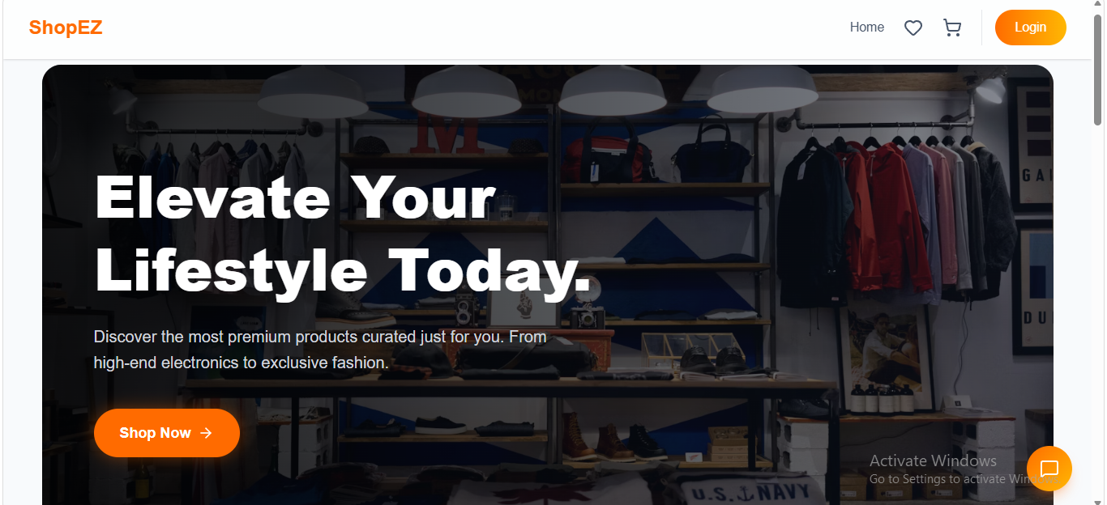

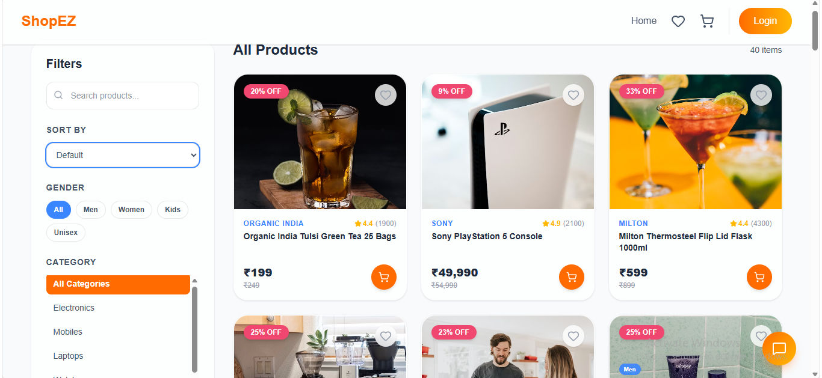

Login Page:

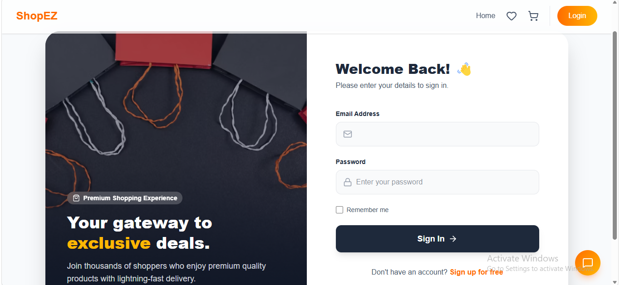

Admin Dashboard:

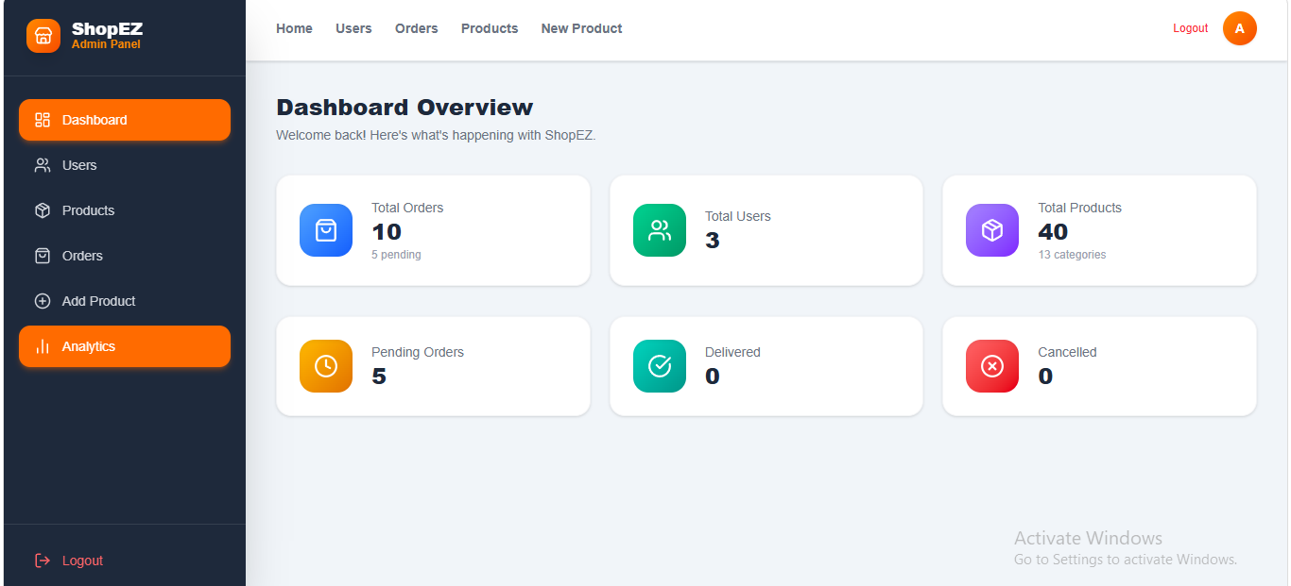

Shopping Cart:

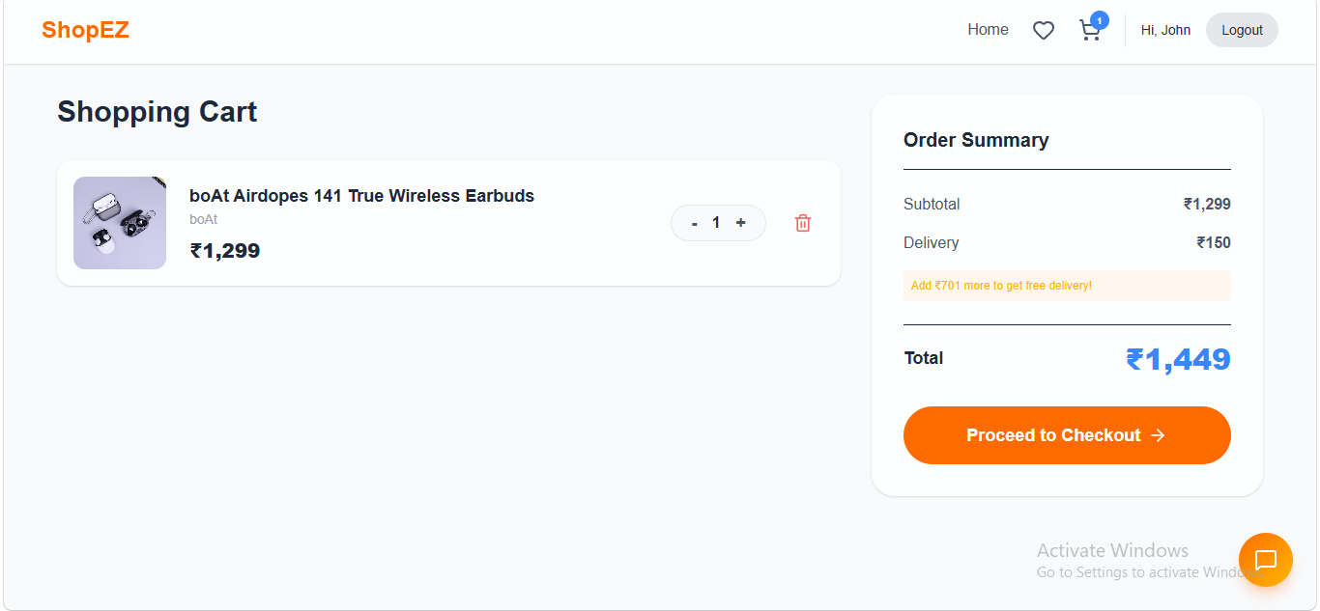
Backend:

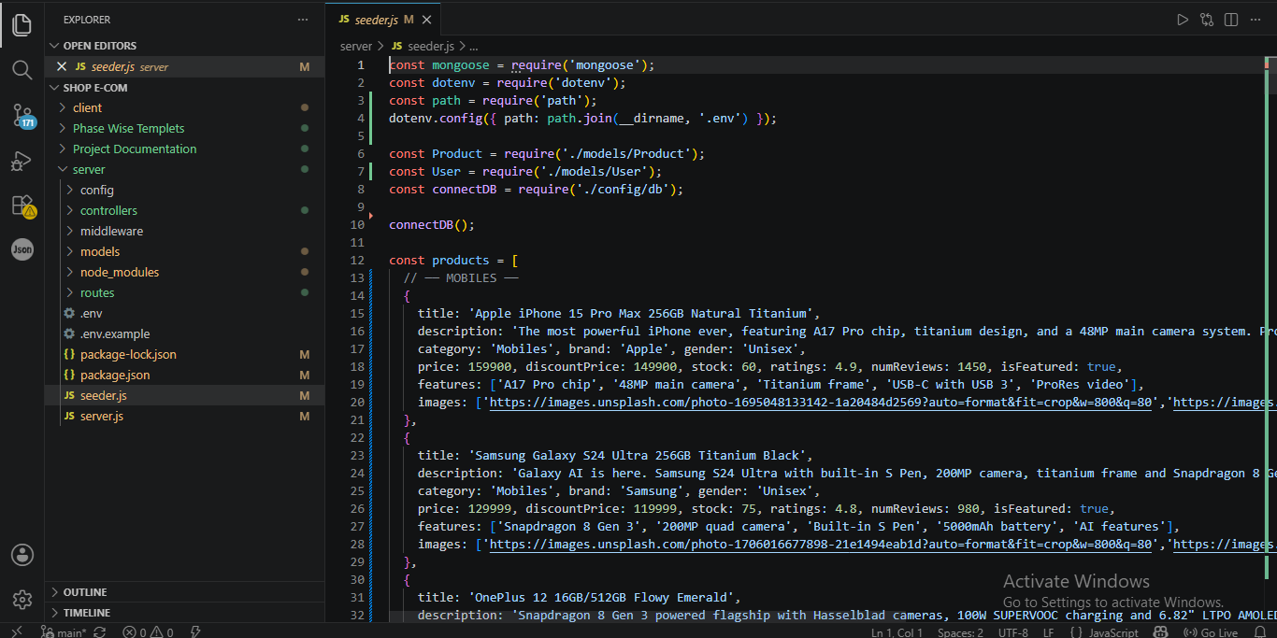 `

Demo Link:

Video Link

12. Known Issues
- Cart total may not update immediately after changing item quantity until the page is refreshed.
- Product image uploads are stored on the local server filesystem (client/public/uploads), which may not persist across certain cloud deployments without additional storage configuration.

13. Future Enhancements
- Support multi-vendor / seller accounts with individual dashboards
- Add email/SMS notifications for order status updates
- Migrate image storage to cloud-based storage (e.g. AWS S3, Cloudinary) for scalability
- Add advanced admin analytics (sales trends, top products, customer segmentation)

